Jump to search
Avard Fairbanks
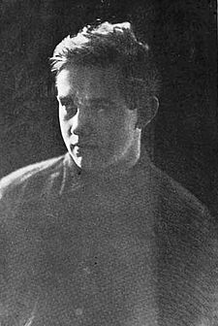
Fairbanks (ca. 1914)
Born | Avard Tennyson Fairbanks  March 2, 1897  Provo, Utah
Died | January 1, 1987 (aged 89)  Salt Lake City, Utah
Resting place | Larkin Sunset Lawn Cemetery  40.741°N 111.823°W
Alma mater | University of Michigan
Occupation | Sculptor
Spouse(s) | Beatrice M. Fox
Parent(s) | John B. Fairbanks  Lillie A. Huish
Avard Tennyson Fairbanks (March 2, 1897 – January 1, 1987) was a prolific 20th-century American sculptor. Three of his sculptures are in the United States Capitol,^{[1]} and the state capitols in both Utah and Wyoming, as well as numerous other locations, also have his works. Possibly his most well-known artistic contribution was designing the ram symbol for Dodge.^{[2]}
Fairbanks studied in at the Art Students League of New York beginning at age 13 and the École Nationale Supérieure des Beaux-Arts in the atelier of Jean Antoine Injalbert beginning at age 17.^{[3]} Fairbanks received his bachelor's degree from Yale University and his master's degree from the University of Washington.^{[4]} For three years Fairbanks studied on a Guggenheim Fellowship in Florence, Italy. He received his Ph.D. in anatomy from the University of Michigan. He was also a professor of sculpture at the University of Michigan.^{[5]}

